Another award winning Newsletter: Very Late October 2004
*Marathon Madness- Reports on our members from many parts of the USA
Hartford, Chicago, Steamtown, the Adirondeck, and more
*A Joe Skelley update from Iraq *Regular race reports *The Legend passes…
*Carol Kane- National Champion!!! *Preliminary Mystic Relay Report- women run 2nd fastest
**The Cow Chip 5K is now a State Championship relay time in Mystic Marathon history!

Editor’s Rambling
Yeh, I know, all for the want of a half second a mile! A 3:00:13 at the Steamtown Marathon. How stinkin’ close…It’s my favorite course at my favorite time of the year so I wasn’t going to let 13 little, stinkin’ seconds ruin my Karma. And I can justify it by remembering I was on crutches last February and was thinking that walking to my bathroom without pain would be a great goal. And then there was my cardiologist in June recommending that, “you probably should stay away from any marathons from now on…”
So, all things considered, I can’t be too upset running my 3rd best marathon ever out of the 35 completed. But just 13 ticks…and maybe that’s what- 26 strides at best? Where did I lose it? I was at 2:15 for 20 miles and thought, “a 45 minute 10k, I got that!” Ahhh, But my favorite course- all 967+ feet of elevation loss thru mile 18- can come up and bite your butt in the last 3 miles, even though I have run it 7 times. That’s where them darn hills are placed. Kinda like Beantown but way later. Even from mile 25.5 - 25.9 there is a good one thrown in.
I knew it was going to be tight just before 25 miles. I was trucking into a little headwind and into the little rise when I went into brain melt looking at my last split- a 7:10 mile. I did a little quick math and realized that I had to work hard and needed a 7 min or under WITH that last hill still to come. Ugly, very ugly, and no one around to work with, just me all alone.
Then suddenly right at the bottom of the hill comes the young 20 something year old guy I had passed at 20 mi. ‘Excellent!’ I thought to myself. ‘Someone to help push me up the hill’… That was until he got 3 strides ahead. There he stopped suddenly, did the classic bend from the knees while teetering over to the right side and blew about a quart of green fluid a good 3 feet to the side. What made it worst in my mind was that there had only been orange Gatorade in the course- no lemon lime!
So I am thinking the kid blew a freakin’ Gall Bladder or something and this is some bile-like fluid! As I whiz past him let me assure you I am not thinking Florence Nightengale but rather how to avoid the projectiles, wish him luck, and not get a whiff! Then just as I am past him I hear another explosion from his oral sphincter. Oh man I thought I was going to lose it right there.
But you will be happy to know I held it together as I crested the hill at 26, and saw the clock.
It was over, both literally and figuratively. The finish was there, but so was 2:59:55 and I still had too much ground to cover. “Look good for the pictures” was the last thing I remember thinking as I heard my name announced. I high fived it across the line, got my little space blankie and medal, and headed for the massage tables. Not bad, 2nd in the old fart division and a nice plaque.
Our teammates had done well: Cindy Pomeroy 3rd woman overall; Joe T. Brady ran a 3:24 qualifier after not being able to walk 10 days earlier (and his 3rd fastest ever); and Ronnie Behringer- another Boston Qualifier. John Farley ran great and then partied at the bar named after him right across the green from the finish. And Steady Shannon Police showed up too! Yep, another great year at Steamtown. You have to start thinking now about doing this marathon. You will love the course, the rails to trails section, the people, the hotel rates, the food in Scranton & the easy drive there. I promise!

The start of Marathon Madness- the highs…

Shannon Hovey in Chicago:
I ran a 2:50:08 is the time. Not bad, better next time I'm sure. Still a 3 minute PR. By the way, Chicago is such an incredibly organized race, the fans are amazing, & the entire experience was fabulous. I look forward to next year! PS. I was 18th woman overall.
Want to hear some very cool news??? I just got a letter in the mail from Chicago Marathon telling me that as 5th American woman I've won $6,000.00!!!! Can you stand it??? I am still in shock!!!!

Joe T. Brady in Steamtown:
A little background before the JTB story~ Joe and I did some long runs together. He’s a hard worker. But 10 days before the marathon he wrenched his back and couldn’t even walk- let alone run. It didn’t look good. I hooked him up with the USA’s #1 massage therapist- Jim Miccio who got to work as soon as was feasible. Then Joe had extensive physical therapy. He actually brought a portable Electric Stimulation device with him! (In my car, talk about Auto Erotica). We ran the last 2+ miles from the finish out and back the day before. And the morning of race day he strode confidently to the buses with anticipation, hope, and a lot of Advil…

Hey Marty, About Steamtown -- where to start? Most important, I can’t thank you enough for all the help and support you provided to me personally. And that goes from the time you suggested Steamtown while putting down a few ‘Stoli Dolies’ following the Beantown Meltdown. Although I kept Chicago in mind right to the end, Steamtown was the right choice this year: a great midsize marathon, just as you said. I thought it was a fast but challenging course -- like Boston, it requires some thought and discipline to navigate the steep down hills early and up hills late. Mostly scenic route with a nice rail-to-trails stretch in the middle just when your legs are ready for a change. Great organization, good crowd support for its size, nice post-race party in an Irish pub...what’s not to like?
Anyway, thanks for the strategic advice and the scouting trip to Scranton...that was really an extraordinary gesture on your part. (EDITOR’S NOTE: Jim and I did a preliminary tour of the course about 2 weeks in advance. I had felt a terrible malady coming on and I needed to use a sick day after accumulating 192 of them)
I still can’t believe I was dumb enough to hurt myself going into the last taper week and put the whole thing at risk. One of these years I will stretch and otherwise stay flexible through an entire training cycle...honest. I spoke with Jim Miccio today and thanked him for the massage work that helped save my race; he reinforced the point that I have some preventive maintenance to work on. The little Hi-Tek group we had in Scranton could not have been more supportive as I weighed whether to run. Everything helped -- not least you, Ronnie, and Cindy toting my
bags like porters and handling all the driving. (EDITOR’S NOTE: Where’s my TIP???)
All in all, a very uplifting weekend. Cindy was awesome, you were the age-group ace, Ronnie showed us all how to negative-split that course, and my buddy Chris Ahlberg ran the
race of his life to qualify for his first Boston after a ton of hard work. I got very, very lucky and am feeling both battered physically and drained emotionally. But relieved as hell. I am heading to the Keys for a few days, without running shoes and with, as the Buffett song says, a license to chill.

Cindy Pomeroy in Steamtown- an easy 8 minute PR
After a fairly ugly Mystic Marathon last year Cindy was probably thinking it was her last stab at the distance. Though she ran a 3:04 and picked up some cash, it was not a fun experience. But her agent talked her into training less and going to a course that would be easier and with less turns. It worked as she placed 3rd overall and first master in 2:56:55. “The $800 was a nice bonus. The course was nice, and the foliage spectacular!” she said later. She ran a conservative race thru the half (1:28) and actually kept her pace thru the tough up hills in the last 3 miles. But that has been her M.O. now for the last three years. Pass ‘em when they’re hurtin’!

3:13 0n 25 mi/week~ the Mary Dunn method to Madness!
The Mohawk Hudson story:
The weather was perfect, 50's at the start. Although I had a good experience, I would not recommend this course. It is too flat, sparsely populated thus pretty boring. I ran a 3:13 on 25 miles/week training for the past two months, so I was not all too disappointed! My legs decided they did not want to play anymore around 24. I don't think I could have gone another 50 yards past the finish line. George Dickerson did a 3:34. It was his best marathon yet. Being that we train together most of the time, he too was under trained which tells me he can probably take 15 minutes off that time pretty easily. Now we all have to get going for the Miami Marathon!!

Rebecca Wright from Columbus~
Steve ran Hartford ... also in 3:28 ... and is trying to figure out what to do between now and the New York City Marathon -- which we are both running in November. He may be racing this weekend, but probably not. No such thing as "too soon" for me unless it's another marathon. Back when I was playing soccer I used to run the Hartford Half Marathon on Saturday morning, play center mid-field for my Farmington Women's Soccer Team in the afternoon, and then run the Baystate Half Marathon on Sunday Morning.

Columbus Marathon Report -
At Columbus the motto is "Our World is Flat", and they weren't kidding.They didn't mention that it was also completely paved with concrete. Perfect weather, 45 and breezy. Definitely PR caliber, so I went out a little to fast, and hit the halfway mark on 3:22 Pace. I got carried away
because I was talking with Tracy Stewart, a 25 year-old from Colorado who had run the Indianapolis Marathon the day before. (ED. NOTE: obviously these two women were separated at birth) She told me she had run 3:01 ... but she didn't mention that she was the overall Women's Winner! (She finished Columbus in 3:27, but said the last 2 miles were pretty rough).
There was a long stretch from about 11-19 into the wind which took a little of the stuffing out of me, but I managed to hang on for a 3:28, 8th F40-49. That's the news for now.

And the lows…

From Kerry Arsenault: Running at the Mystic Marathon~
Hi Marty, I just blew up but I did finish. I started to walk at 20 miles. The pain in my body was just unbearable. I was over trained/injured and I did not feel too confident at the start. I had some stomach cramps that were very painful-worse than usual -that night after the marathon. But I'm doing better now, thanks for asking. I am now taking the time off maybe all winter. I feel totally burned out. I don't have that urge to run anymore at this point-a sure sign of over training. I ran it in 3:33, not bad even for walking/jogging the last 6 miles. I just wanted to make it at that point. I had an awesome year and I am grateful for that.

And some non- marathon news…

Goodbye Hospital Bed, Hello National Championship- the legend of the Kaniac continues

When we last saw Carol Kane she was in a Norwalk Hospital bed, IV in one wrist, internet connection in the other. And while rest and recovery were the norm for most ‘E. coli’ infected
kidney patients Ms. Kane felt doing ‘hall interval work’ with her IV trailing her on wheels was really the best therapy.
And you know what? When you win a National Championship a few months later, who-in-the-hell am I to question it??? So while the rest of us were in bed Sunday the 17th the ‘Kaniac’ climbed & kicked ass along her way to the 5K Cross Country National Championship while maybe even wearing her HiTek singlet!!! (See Maureen, Bec & others- it doesn’t slow you down!) So here is her story. As usual loaded with DRAMA and all these little dots…that she sprinkles in all…over…the…place!!!

Hi Marty- Yes, I'll write something on nationals. Personally, it was an awesome experience... really didn't expect anything.....it had been a goal since my win at snowshoe nationals this year...would be kind of fun to tuck away a couple different running titles to exit the 50's with. But then mid-August I got hit with hat monster bacterial infection that nearly killed me (actually, the week in the hosp nearly did me in) and thought XC nationals was totally out of
reach....I was left feeling very weak for the next month....so I took an un-kaniac approach.... started a slow comeback from the illness...really didn't decide until the day before to go to Saratoga and I only went to drive George (haha) and for the experience....to just run my best for that day....turns out it turned out pretty good...you never know...you just never know....it was a real humbling experience for sure and I'll write longer on it in the near future...I'll tell you something, if you ever want to win a National Championship race, just take George Buchanan with you and have him yell at you on the course...everywhere on the course!!!....you'll definitely run faster...I guarantee it!!!

The HITEK results at Saratoga- http://www.usatfadir.org/usamasters5k.htm
2004 USA MASTERS 5 KM CROSS COUNTRY CHAMPIONSHIPS
It wasn’t even close. I just hope it was not too demoralizing for the 2nd place woman…
FEMALE AGE GROUP: 55 - 59
1 30 Carol Kane 59 Weston CT 22:57 almost TWO full minutes ahead!
2 36 Barbara Spannaus 56 Minneapolis MN 24:32
MALE AGE GROUP: 45 - 49
1 2 Thomas Dalton 46 Schenectady NY 15:12
2 7 Bob Winn 45 Ogunquit ME 15:52
3 11 Chuck Shields 45 Abington PA 16:05 4 13 Bob Carroll 48 Orchard Park NY 16:17
5 14 Rich Burns 49 Saugus CA 16:21
6 17 George Buchanan 46 Stamford CT 16:29

MALE AGE GROUP: 40 - 44
1 1 Brian Pope 41 Oxford MS 14:54
2 3 Peter Magill 43 South Pasadena CA 15:17
3 4 Oscar Gonzalez 40 Trvine CA 15:19
4 5 Tony Young 42 Redmond WA 15:29
5 6 Gary Griffin 43 Rochester NY 15:35
6 8 christopher chisholm 42 farmington CT 16:03

Not HiTek and Not Human: AGE GROUP: 60 - 64 1 Bill Borla 64 Torrington CT 18:14

Mystic marathon relay results- another state championship dominated by HiTek

SENIOR MEN KICK BUTT: Written by Team Captain Paul Shanahan
Our Senior Men (is that a redundant phrase in Spanish?) came together when it counted most and sped to victory at the not so Mystical Marathon ‘de Wind’ on Oct. 24.
Congratulations to Paul, Lee and Mark for an outstanding marathon relay Sunday, a 3:11, which was 19 minutes better than Housatonic Road Guys. As a result we won the USATF/CT Seniors competition for this year, making it 3 years in a row.
Special recognition goes to Mark, who was a huge addition to the team at midyear, and to Bob Marum, who although he is not the fastest guy on the team is always ready to help us out and without whose participation we would not have won.
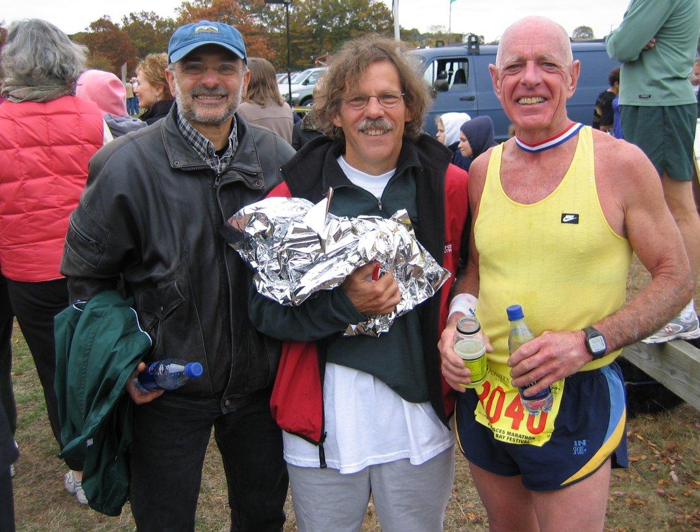
Hitek Seniors total time 3:11:42
(l-r) Paul Couzelis - Lee Bradley- Mark Turkington

Another first place!
AFHITEK WOMEN 3:01:20
CINDY POMEROY - REBECCA WRIGHT –
ELAINE ROMAINE - REBECCA STEINKRAUS -
CINDY SCANNELL

The following Mystic report was written
by Alan MacDoudall
Mystic Places Marathon Relay Results
***AFHITEK MASTER WOMEN 3:01:20 14th Overall TEAM
That's right. These women were the 14th overall relay, the first women, and they beat 15 of the men's teams! What can we say about a team that's this good? Well, they ran the second fastest women's relay time in the history of the event.

***AFHITEK GRAND MASTER WOMEN 3:47:45
SHARON MENDES - BARBARA MALONEY - JANE PEARL (new member)
They were the fourth team in the masters/grandmasters division and beat Silk City's Masters Team. And that's not all- Sharon Mendes ran a 4:15:49 for the whole marathon.
***AFHITEK Hitek Senior Men 3:11:42
They won their division and beat at least one Master's team, and two of them ran two legs of the relay to boot. These guys were so ready to run that they showed up with an alternate !
***AFHITEK OPEN 2:44:01 6th Overall
JEREMY HOWARD - MICHAEL WIXTED - alan macdougall - CHARLES HORNAK - RICHARD KORBY
How good was the competition ? These guys got beat by two of the men's master's team. Jeremy Howard ran the whole marathon and qualified for Boston with a 3:09. One of their runners ran sub-sixes for 8.3 miles.
More Mystical News and Notes: Chris Schulten broke 3 hours for the 4th time (that's this year). Eight days AFTER he completed Ironman Hawaii !

Other races with some fresh faces:

Martha Merz and Family invade our Nation’s Capital:

I had a great time at the Army 10 mile race. It is such a well-run race, esp. considering that there were 20,000 registered! Having done it many times before, I have the logistics down, you know, the favorite bathroom spot, leaping over jersey barriers into a pile of humanity and elbowing my way to the front. I saw Kevin Gallerani there at the start (a fellow CT runner and Mohegan strider). I went out kind of fast because I saw some of my old DC running friends, but quickly settled in. I ran 60:51, which was a little slower that I had hoped, but with my lack of serious training, not surprising. I did win the masters award, which was a huge trophy and a $200 Southwest voucher. I was 9th overall female. The competition was a little steeper this year (lots of young fast chicks in bikini outfits!), I think because of the 20th anniversary celebration. Dan Brown won the men’s race, which he usually does. He is on the Army team. You certainly get a dose of Army patriotism at this race, which is great. The course is fantastic if you want a tour of the city, from the Pentagon to the monuments, across the Potomac River and to the Capitol. All in all, a great experience...again.
My daughter Caroline managed to get to the Freshman dance without me and doesn’t sound like she needed me for her good time. Glad I was able to leave her behind and not subject her to my running insanity. We drove down Saturday morning, stayed the night at my brother's house and drove back after the race. The boys were great, but of course I had to set up the TV and Playstation for them in the car. Needless to say, I was a little stiff when I got out of the car when we got home.

The Joe Skelley Report from Iraq: (as forwarded from Jim Gerweck)
In our last newsletter Joe had just arrived in Kuwait. Now it’s for real…

Hello Everyone in CT,
Greetings from Iraq. I arrived on Saturday in Baquba, my final destination. It is a city of 450,000, 40 miles Northeast of Baghdad, in Diyala province. It has a mixture of Sunnis, Shiites and some Kurds. Very volatile city, scene of uprisings in April and June, due to an angry minority of the population. Home to ex-Baathists, foreigners, Al Qaeda, Iranian agents... definitely not Mr Roger's neighborhood! The vast majority are decent, hard-working citizens glad to have the Americans here, ecstatic to be rid of Saddam, and eager to turn their country around. Many are supporting our efforts, publicly and/or privately. Numerous conversations in the last 24 hours have unquestionably confirmed this sentiment. That said, the insurgents are
ruthless, and target Iraqis who work with the Coalition. I have heard some heartbreaking stories already, it is hard to believe the cruelty. But I have heard many uplifting ones as well. The
courage of so many of the Iraqis is inspiring. I can send you more details on this soon.
Being in a civil affairs unit in the Army, my duty station here in Baquba is at a location
called the CMOC, the Civil-Military Operations Center. It is a type of HQ. We work closely
with the local and provincial governments, the governor's office and his ministries, the State Department, and some NGOs, under the command of the Army leadership at brigade and division levels, on a variety of projects and missions, all geared to stabilizing the province. I will be working on higher education (including the rebuilding of the local university, which was damaged in the June uprising), government relations, national and local elections, and many other projects and issues that will arise.
The CMOC is a compound, with several buildings, all on approximately one city block. (Good news: gym with a treadmill and a 1/4 mile path around the perimeter, so I can get some runs in! I even ran this morning.) The CMOC has a high-visibility presence in the city, to attract locals and to build trust. But that also makes us a target. Occasional mortar and RPG rounds, and echoes of IEDs, make things interesting. We know the insurgents are constantly scheming things, but our search and destroy patrols and intel are pretty effective. In a nutshell, we are in one of the cockpits of this entire war. The next several months will be critical. We will surely hold this ground! Joe
I am getting some runs in, on the treadmill in the gym and on a path around the perimeter (approx. ¼ mile). Not bad, considering I am in a combat zone! I am working on many interesting projects when not manning a machine gun on a Humvee. There is scope for sponsoring some running activities. A Baquba 5 Miler is not, alas, feasible given the security situation. But there is great interest here in sports, and some sustained interest in running, at all levels. As a result, I have two possible ideas which I will share with you soon.

MAILING ADDRESS:

Skelly, Joseph, SGT
A Co, 411 CA BN, CMOC Baquba
OIF2, FOB War Horse
APO AE 09392

The Boston Legend is gone:
The legendary marathoner Johnny Kelley died on Wednesday Oct 6 at
at 97, just three hours after entering a nursing home,
according to the Associated Press. He won the Boston Marathon
twice, was second over a dozen times, and ran in it a mind boggling 61 times.

New members:

Always nice to welcome new faces, and these are as new and fresh as it gets. And speedy too!

Jane Pearl was actually with us many moons ago. And then she skyrocketed to National and World age group fame in the Duathlon. Hopefully I’ll dig up some dirt, err I mean dig up some results from the last year or two. In the meantime she joins us just in the nick of time to complete our Magical Mystical Places Tour de Relay on October 24th.
“Hi Marty-Oh, and I did come in 2nd at the Hartford Marathon in the 55-59 age group. My time was, I think, 1:52. I told you I was running slowly!”
We are very happy to have Jane with us and helping to complete our GM team in the future.

Jeremy Howard came to us by way of me bugging him to join! No seriously, he’s a great young addition and jumped right into the team effort by running the first leg of Mystic for us (and continued for a 3:09 finish!!) We look forward to his growth and friendship in the years to follow.

Members at the races:

Jim ‘newlywed’ Tharp: (Glastonbury Applefest 5k 18:18 5:55 pace) Glastonbury 5K course was great on 10/16! Prizes to 1st & 2nd only all age divisions, but the booty was 1st all division an apple pie and Timex running watch! 2nd all got an apple pie and orange reflective running vest, 1st overall the same as first age divisions plus a $50 gift certificate to some running joint, second the same as second overall plus a $30 certificate. Course is rolling hills but not so that they put a dent in your overall pace :>)

Rodney Fur’s XC race results thus far...
Fitchburg State Invitational, 10 September: 3rd place/26:12 for "just under 8km"
Williams College Invitational, 25 September: 24th place/18:28 for 5km

Newest member Jeremy Howard:
I decided to run the entire Mystic marathon and am already signed up so I guess I can just be added onto the first leg of the relay? That is going to be my first race since the Pamby-Ridgefield Half (1:23:23.) I also ran the New Haven 20K (1:19:43) and the Fairfield 30K (2:00:17).

Heather Crosby- gearing up for a sub 3???
Marty - Much thanks about the sneakers and the words of encouragement on the Ridgefield Half race course on Sunday. It helped me catch two women. Now I have a new 1/2 marathon PR! Gracias! (EDITOR’S NOTE- glad I could help. You looked smooth as silk)

On the Wright Track?

Our monthly column from our beloved “Bec” Wright- runner extraordinaire…

My report on my Kaniac-style September:
9/12 Stowe Marathon - 3:52 - 6th Woman, 3rd Master (they double-dipped)

In honor of my Birthday the Race Director gave me #42

9/17-18 Reach the Beach Relay - ~30 Hours (200+ Miles)
Mid-Pack Finish for my 12-person "Henniker Running Club"Mixed Masters Team

9/25 Lake Winnipesaukee Relay - ~9 1/2 Hours (65+ Miles)
2nd Place "Silk City Striders" Women's Masters Team
(8-person team with Barb Maloney)
(Also, Lee Bradley's "Oldies But Goodies" Men's 60+ Team Placed 1st in their Division, beating my Women's team by almost 45 minutes.)

Letters to the Editor:

Marty, Thanks very, very much for your messages. Great to hear from you. And the newsletter is fantastic! Such a nice publication to read out here in the middle of Mesopotamia, brings back great memories of running in CT. Autumn is one of my favorite times of year to run in CT...I will be thinking of you guys tomorrow morning as I run on the treadmill and then do a few laps around the perimeter (my sniper run, I call it!). I'll stay in contact. Joe Skelly

From Karen Neuman- I WISH I could run. I tore my plantar facia in July and running has been a nightmare. I have only run 4 times since July and it hasn't been pretty. I did manage to place second in Hammerfest overall...behind the wonderful Mary Dunn and then won my age division at Westchester and even beat some elites.. but it wasn't because of my run...in fact.. I don't think I have ever run slower in my life. I am off to try to get it fixed...heading to New York. Good luck to the girls and I hope to be running again next year.

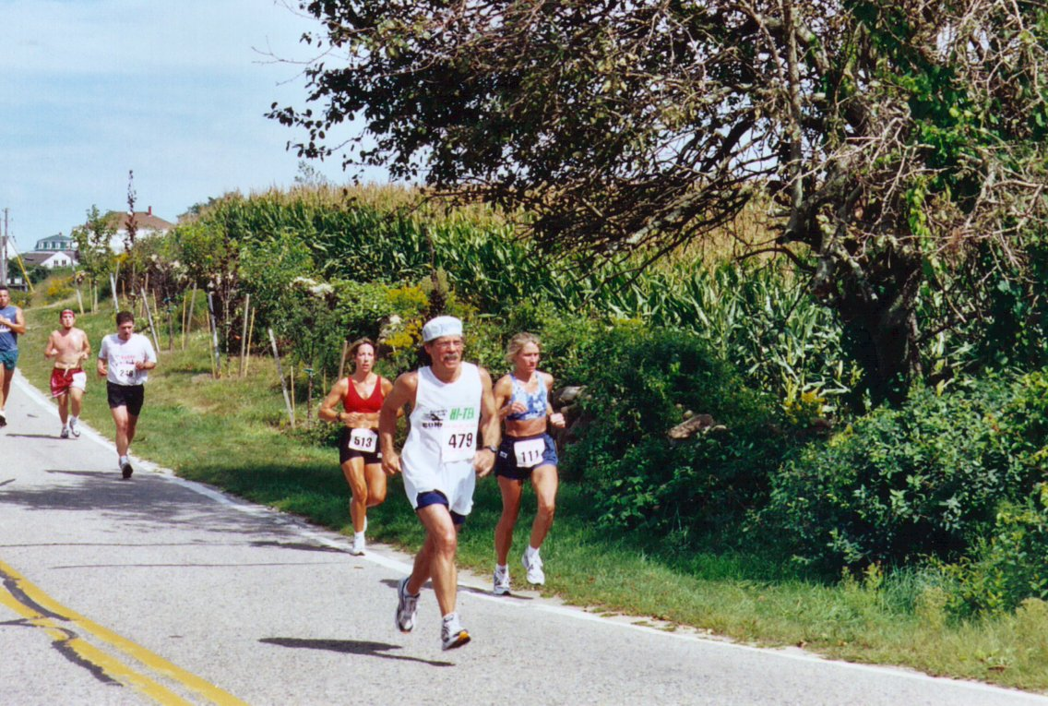

This is Lee “too much time on my hands” Bradley at one of his favorite races- the ‘Run around the block 15K’ on Block Island. Lee has quite a posse’ with him at these races so if you are thinking of hooking up please call ahead.

Tri Stuff:
Well, we know Chris Schulten did Hawaii Ironman! But I have no idea how he did. And I guess the water is tooooo cold now so the tri-babies pack it in to avoid the dreaded “Shrinkage” of George Costanza fame.
Alan Macdougall is going down to do Ironman Florida in November so I am sure we will hear from him in the next newsletter.
We get letters…

Rodney Fur (flying) reports from Mass.
Despite my dissatisfaction with my own performance, I was happy to make the drive to CT for the XC race. The trip south wasn't too long -- it only took me about 1 hour and 45 minutes -- quite "do-able" in my book. Kevin's course was good and challenging and I was glad to test
myself against it. And of course doing so whilst wearing the Hi-Tek racing kit made it all that
much better.
In Saratoga: I had taken a quick look at the results and saw Chris and George did good. However it's wonderful news about Carol. I'm glad the club can boast a national champion. We are lucky to have such a hard charging harrier in our ranks.
I'm off to Nebraska this weekend for a wedding and then will do the Marine Corps Marathon the next week. I'll shoot you an e-mail from that event to let you know how it goes.

Shannon Police after Steamtown:

It was sooo nice to see you over the weekend. and congrats on the age award! i was over by baggage trying to warm up my legs for the 5 block walk back to the radisson when i heard them call your name out! how exciting! taj said she saw you finishing up and cheered for you!
So you're a veteran steamtowner? this was my first time doing this race, but i don't think it'll be my last. i'm already contemplating if i will do it next year (i had my mind set on hartford, but now i don't know). this was not a PR race for me by 4min, but by far it rewarded me in other
ways. i took this event as an opportunity to learn the benefits of proper pacing. all my friends talk about training at marathon pace and so forth, and i never really took it seriously. so i decided to try it out---the catch was that i'd try it out DURING the marathon! silly, i know! my goal was to stick with 10:30 pace, and i did. my fade didn't hit me until mile 23. and it wasn't that i was exhausted or anything, but i had plenty of questions as to what caused it--in the end, i think maybe i could've used more gel, but i'm not sure on that. lots more experimenting to do. it's opened up a new world for me...now instead of going into a race with a goal finish time, i will have a goal split time to stick with...i will look at my watch consistently, something i'd always been afraid to do, and not HOPE for the best, but PLAN for the best.
anyway, i ran yonkers marathon 3wks prior to this with a 4:51 finish time.well off the 4:40 i was looking for. steamtown yeilded me a 4:42 and a better sense of contentment. i will get better at this and hope to lower my 4:38 pr soon. So rest and recover well!
Late Breaking Pumpkin Classic race news: 10/24 Well, Kate O’Neill couldn’t run because of a high hamstring tweak but twin sister made up for it and won the women’s division in 22:19. Meanwhile our own Bryan Kovalsky ran a splendid race (20:00 -5 min. pace/mi!) out-dueling Oscar Gonzalez (20:09) who is 40 and a new CT resident from CA. Ironically Oscar ran against George Buchanan and Chris Chisholm last week in Saratoga. Other teammates: Shannon Hovey was 3rd and Heather Crosby a strong 4th. Chris Chisholm 5th (20:53) Tom Harding 7th (21:49), Dale Richardson 1st Trumbull resident- 9th overall (22:55).
Complete results: http://www.hitekracing.com/results04/pump1024.htm

Jay “Mr. Pumpkin Head” Wilson: (who ran great again at the Pumpkin Classic- 28:48)
I know you wanted me to let you know what I've been doing. The last time we talked I was training for a tri in Madison. I finished 3rd in my age group there and last weekend I won my age group at a road race that my whole family does in Cobleskill NY. It's a big race for that area with about 700 finishers and they donate all of their proceeds to several area charities. For winning my division (in addition to a medal) the division winners get stocks from a local company as a prize!! The stocks were worth 95 dollars this year and what made it especially nice was, I was able to donate that to one of the charities.

Sharon Vos from her “Hospital-House Ward”
Well, considering that you couldn't move in Dec. not a bad run!! I'm just a mess at the moment. My back and neck are healing and I feel ok but don't really know for sure because I've run so little that I can't tell if the improvement is from not running or from the shot, PT, etc. I now also have quite a cold that seems to have hit in my throat and ear - I've got quite the deep voice at the moment!! I had hoped just maybe to still be able to get in shape for NYC but that is definitely out. Then I had thought maybe Philly but I think I'm just playing with fire. I'd really have to get in another long run and race to see where I'm at and have had trouble because of the recovery, then cold. I never would have fathomed in June that I'd be not able to run a marathon and am surprised at how much has happened.
Joost (husband) is doing PT now after his surgery and is well on his way. His neck is good and he should have no issues at all. Jen has 2 more weeks in the boot cast and then can go into a shoe with a steel plate for another month. I'll be so glad when she can get back to normal and play tennis, etc. She just starting to take the bus so that also makes my life a little easier. She's a real trooper.Sophie, after her ear infection, seems fine and is busy with field hockey and tennis. She's really quite an athlete.
I'm dying to run a marathon! Not much other news. Whatever races I do at this point will definitely be with the goal of just getting back in to shape. Take care and I still think a 3:00 is great. I can relate with the issue of seconds. Remember my Hartford (I think 3:19 secs. and one Boston was 3:00:03) Frustrating I know! See you soon. Sharon

Steph Hahn, back from assignment in the land of food and wine…
We have returned from our 2 weeks of eating, drinking and biking in Italy. It was another fabulous time and hard to get back to the real world. We spent 1 week in the Portofino to Monte Carlo area and then headed to the Piedmont region for our biking.

We had Michael Romano, Executive Chef of the Union Square Cafe, on the trip so had nothing but the best in food and wine! We biked about 40 miles a day through some beautiful vineyards and countryside and, of course, hills! I must say that I was in much better shape to due to increased running mileage and track work. I surely limited my stiffness and increased the enjoyment immensely! I can't say enough for these "active vacations"! It makes the eating and drinking guilt free!

I am sure it will take a couple of days to get back in the swing of things. We're digging out of our stack of mail right now. But I’m trying to get my calendar in shape since I'm off to Florida on Monday to check on our home. I'm returning Thursday so will be back the “Pumpkin”. I’ll see you there!
Nancy Shaw, one of our classic GM’s. is getting back to business:
It was great to hear from you. Well the girls are fine my son is in Fort Sill, OK. He is coming home for Christmas and than leaving for one month in Kuwait and than 1 year in Iraq. So I am very excited for xmas to come. I am doing well, I have recently lost the weight I wanted and am now starting to get back in shape going to the gym and starting to run very slow. I am so missing being out on the roads. I have been really busy taking care of the house and yard this summer I didn’t have much time for me. Winter is a good time to train so by spring I hope to be racing. My legs feel good I gave them the longest rest they have had in years! See you!

Websites for October:
My friend and running buddy Steve Sylvestro hopes you can check out his talented son’s website. The guy is a fantastic musician and has a lot going on. Just tap in and register today!
www.christopherrobinband.com

Want to have some fun? Try this little frustrating bugger!
http://uk.download.yahoo.com/ne/fu/dodge.html

Supposedly the BEST photos of 2004: you be the judge.
http://ops.tamu.edu/x075bb/BestOf2004/

“I love I love I love my calendar girl(s)” Anyone remember that song???

FEMALE ATHLETES BARE ALL TO SUPPORT TEAM USA MONTEREY BAY
2005 Wall Calendar Ready for Release October 12 MONTEREY, Calif.
The 2005 wall calendar "Strength and Grace: Monterey Bay Women Athletes" is not for the
faint of heart. The calendar, however, is for anyone who appreciates the elegance and
beauty of the athletic human form.
"Strength and Grace: Monterey Bay Women Athletes" will be officially released on Tuesday, October 12 in Carmel, CA as a fundraising project for the Team USA Monterey Bay Distance Running Training Center at California State University, Monterey Bay.
The calendar, which has a retail value of $20, is offered as a complimentary gift for Team USA Monterey Bay supporters who make a minimum tax-deductible donation of $25 to the non-profit organization. All donations are used to directly support Team USA Monterey Bay's
mission to develop U.S. stars in the sport of long distance running and to provide athlete role models in the general community who promote physical fitness and healthy lifestyles.
The 2005 wall calendar contains photos of 13 local female athletes, ages 20 to 60, who posed "au naturelle" for photographer Helen MacKinlay's camera in support of Team USA Monterey Bay. The black and white images emphasize the beauty of line and form of the athletes who
remain anonymous in the calendar. The project is MacKinlay's follow-up work to her 2004 calendar, "The Full Monterey: Sexagenarian Male Athletes," which contains photos of male athletes age 60 and over. The 2004 version brought in over $4,000 in donations for the running center. MacKinlay's husband, Rod MacKinlay, who sits on Team USA Monterey Bay's Board of Directors, helped produce both calendars.

Jokes from our members- honestly!

*How do you know when you're staying in a West Virginia hotel? When you call the front desk and say, "I gotta leak in my sink," and the clerk replies, "go ahead."
*What do they call reruns of "Hee Haw" in West Virginia? Documentaries.
* A West Virginia State trooper pulls over a pickup on I-64 and says to the driver, "Got any I.D.?" and the driver replies "Bout wut?"
*Did you hear about the $3 million West Virginia State Lottery? The winner gets $3.00 a year for a million years

From our buddy- Lee ‘too much time on my hands’ Bradley:
http://www.primepuzzle.com/leeslightest/lunar_eclipse.html

Ilse Berkeley sent this:
A man is driving down a deserted stretch of highway when he notices a sign out of the corner of his eye....It reads: SISTERS OF ST. FRANCIS HOUSE OF PROSTITUTION 10 MILES
He thinks this is a figment of his imagination and drives on without a second thought. Soon he sees another sign which reads: SISTERS OF ST. FRANCIS HOUSE OF PROSTITUTION 5 MILES Suddenly he begins to realize that these signs are for real and drives past a third sign saying: SISTERS OF ST. FRANCIS HOUSE OF PROSTITUTION NEXT RIGHT
His curiosity gets the best of him and he pulls into the drive. On the far side of the parking lot is a stone building with a small sign next to the door reading: SISTERS OF ST. FRANCIS
He climbs the steps and rings the bell. The door is answered by a nun in a long black habit who asks, "What may we do for you my son?" He answers, "I saw your signs along the highway and was interested in possibly doing business...."
"Very well, my son. Please follow me." He is led through many winding passages and is soon quite disoriented. The nun stops at a closed door and tells the man, "Please knock on this door." He does so and another nun in a long habit, holding a tin cup answers the door... This nun instructs, "Please place $100 in the cup then go through the large wooden door at the end of the hallway." He puts $100 in the cup, eagerly trots down the hall and slips through the door pulling it shut behind him. The door locks, & he finds himself back in the parking lot facing another sign:
GO IN PEACE. YOU HAVE JUST BEEN SCREWED BY THE SISTERS OF ST. FRANCIS. SERVES YOU RIGHT, YOU SINNER

Ask Mr. Answer:
Q: I've heard that cardiovascular exercise can prolong life. Is this true?
A: Your heart is only good for so many beats, and that's it...don't waste them on exercise. Everything wears out eventually. Speeding up your heart will not make you live longer; that's like saying you can extend the life of your car by driving it faster. Want to live longer? Take a nap.
Q: Should I cut down on meat and eat more fruits and vegetables?
A: You must grasp logistical efficiencies. What does a cow eat? Hay and corn. And what are these? Vegetables. So a steak is nothing more than an efficient mechanism of delivering vegetables to your system. Need grain? Eat chicken. Beef is also a good source of field grass (green leafy vegetable). And a pork chop can give you 100% of your recommended daily allowance of vegetable products.
Q: Should I reduce my alcohol intake?
A: No, not at all. Wine is made from fruit. Brandy is distilled wine, that means they take the water out of the fruity bit so you get even more of the goodness that way. Beer is also made out of grain. Bottoms up!
Q: Is swimming good for your figure?
A: If swimming is good for your figure, explain whales to me.

Rodney Dangerfield, Comic Seeking Respect, Dies at 82

I think there is a little Rodney in all of us…
"I was an ugly child. I got lost on the beach. I asked a cop if he could find my parents. He
said, 'I don't know. There's lots of places for them to hide.' "
"My fan club broke up. The guy died."
"Last week my house was on fire. My wife told the kids, 'Be quiet, you'll wake up Daddy.' "

Cross Country Grand Prix notes- Don’t let another fun year pass you by!
OK- First of all I am going to do what I have done for 3 straight years and that is to PLEAD with you to PLEASE come to these races! They are fun- it is different then the roads, you DON’T
HAVE TO BE FAST! Just BE THERE! USATF money is sitting there waiting to be won- and teams don’t show up. It’s a shame, really. Our men and women could win these and there’d be enough $$ for a free winter party again!
If anyone wants to take on the responsibility of coordinating the men’s teams or women’s for this we will pay all entry fees for you. Such a deal!

Heather Panciera WON the 10/16 race in 20:08. Rodney Furr was 8th overall in 17:58. Unfortunately those were the only HiTekers!

10/16 | Stenger Farm 5K O/M Waterford Registration  860-439-0222 RESULTS
11/7 | Sunny Brook 5K O/M  Torrington Registration  www.greystoneracing.net
11/20 | West Hartford 8K O/M  Farmington Registration  www.hartfordtrackclub.org
11/27 | Cow Chip 5K  Trumbull Registration  Meet Information

There are Open and Masters divisions in the Xcountry grand prix. And our grandmasters are needed because you could score in the masters division.

*The next race is Sunday Nov. 7th in Torrington. It is NOT a tough course and Torrington is close to Waterbury so our Northern Tier Alliance folks could go. Now here this- All we need is 3 women and 5 men- and you could all be masters and also score down into the open division. At the rate that teams DON’T show up you might almost win by default.
*The Nov. 20th race is a good challenge- I have done it 3 years in a row and had an asthma attack at one of them- HA! Only kidding! That’s the one A LOT OF TEAMS go to. And as for
**The Cow Chip Cross Country 5K 11/27- Hey I guarantee you have fun or else. (Flier attached). A great, easy course all around the grounds here at Trumbull High where I am actually typing this newsletter as we speak. Tremendous brown food & a chance to win $5000!

But we need you! And for those that feel they can never score (for the team points that is) – Well, HERE IS WHERE YOU CAN. There will be a USATF rep. At each one so you can sign up and actually have it count for 2005 as well. BRILLIANT!!
And as an added incentive HiTek will pay for Coffee ‘And’ for teammates after each event. We will need someone to keep receipts and we will reimburse you. I will be away, working on the 7th and 20th so we will need someone to keep track of this for us. Call me at 203 374 6433
or email msrunningproductions@yahoo.com . Or reach Alan cyberpunk@mac.com

Ask Mr. Nutrition:
How much protein do athletes need? The current dietary reference intake for protein for age 18 yrs. and over, is 0.8 grams per kilogram of body weight per day (i.e., 80 g of protein for a 100-kg (220-lb) person).
However, many sports nutrition experts have concluded that protein requirements are higher for athletes. The additional protein may be needed in order to promote muscle adaptation during recovery from exercise in several ways:
• Aiding in the repair of exercise-induced damage to muscle fibers.
• Promoting training-induced adaptations in muscle fibers (e.g., synthesis of new proteins that are involved in energy production and/or force generation).
• Facilitating the replenishment of depleted energy stores.
The American College of Sports Medicine (ACSM), American Dietetic Association (ADA) and Dieticians of Canada (DC) recommend that (see reference above):
Protein recommendations for endurance athletes are 1.2 to 1.4 g/kg body weight per day, whereas those for resistance and strength-trained athletes may be as high as 1.6 to 1.7 g/kg body weight per day.
These recommended protein intakes can generally be met through diet alone, without the use of protein or amino acid supplements, if energy intake is adequate to maintain body weight.
Some of the implications of the ACSM/ADA/DC Position Statement are that:
Individual protein requirements may be influenced by the size of an athlete as well as the demands of his/her sport (i.e., whether the sport is mainly "endurance"- or "strength"-oriented).
For example, a 60-kg (132 lb) cross-country runner might require 70-85 grams of protein per day, whereas a 100 kg (220 lb) football player might require up to 160-170 grams of protein daily.
Athletes require ~10-15% of their daily energy intake from protein, provided that sound nutritional practices are followed and energy intake is sufficient to maintain body weight. If, for example, an athlete consumes 3,000 kcal and 10% of those calories are from protein, that's enough to provide 75 grams of protein (3,000 x 0.10 / 4 kcal per gram of protein).
Athletes can meet their protein requirements through diet alone, without the aid of protein or amino-acid supplements, as the typical North American diet is rich in protein-containing foods.
Vegetarian athletes should also monitor their food choices carefully.

