bill's and frank's age is 17 and bill's age
is twice as old as frank will be when frank is
three times as old as bill was six years ago.
How old is bill?

b0 + f0 = 17 equation 1
b0 = 2f1 equation 2
f1 = b2 equation 3
b0 - b2 = 6 equation 4
f0 = f2 = 6 equation 5
f1 - f0 = b1 - f0 equation 6

My secret was that I let bill be 12 and frank be 5. 12 + 5 = 17.

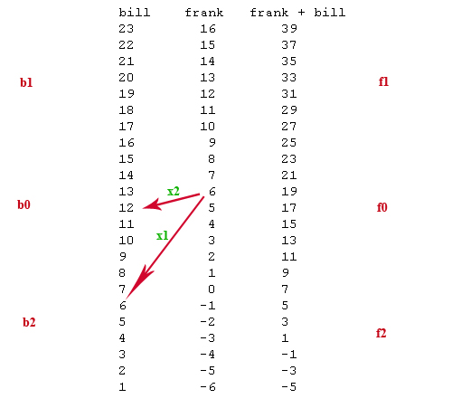
B1 = future
F1 = future
B0 = present day bill is 12
F0 = present day frank is 5
B2 = past
F2 = past

Now, let’s consider the “system of 2 equations in 2 unknowns.”

1b + 1f = 17 (because 12 + 5 = 17 from above)
2f + 6f = 54 (because 24 + 30 = 54)

Solving for b in the first equation, we see that b = (17 – f)
Therefore, using the substitution method in the second equation, we see that

2(17 – f) + 6f = 54 or
2(17+5f) = 54
34 +10f = 54
f = 2

Therefore, b = 15 because 17 – 15 = 2

The following (from above) can be written as a matrix equation

1b + 1f = 17
2b + 6f = 54

Here is the matrix equation:

[1 1] [b] [17]
[2 6] [f] [54]

The following is a review of how to not change anything by multiplying by 1 in matrix format

[6 -1] [1 1] equals [1 0]
[-2 1] [2 6] [0 1]

